honeypot script

1. the user need to choose one of the services below or all together.

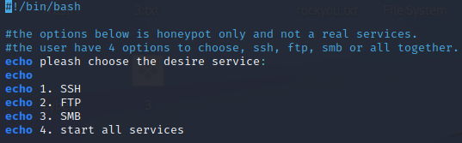

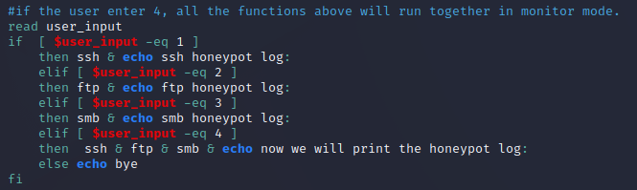

the services will run in a different windows in monitor mode and each input will saved

in relevant log text and all of them will saved in global log script “honeypot_log.txt”

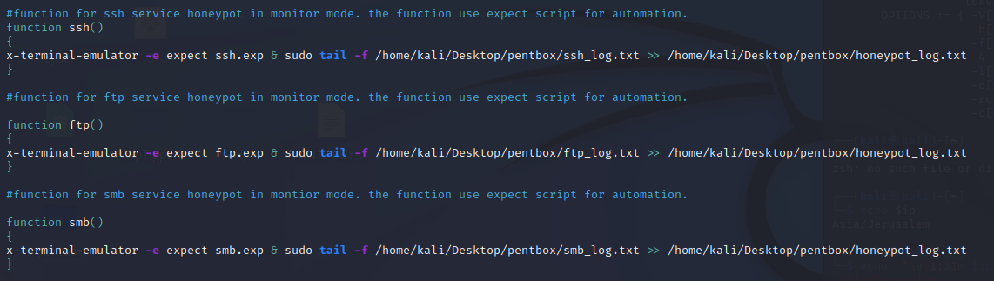

2. LOG function that takes the honeypot log script and extracts the ip’s only and checks

their location.



|  |  |
| --- | --- |
| 3. | SCANNING function that scans the malicious ip’s with nmap tool for open ports, |

services and operating system and save the data in text file “ip_nmap_scan.txt”



ssh outpot:

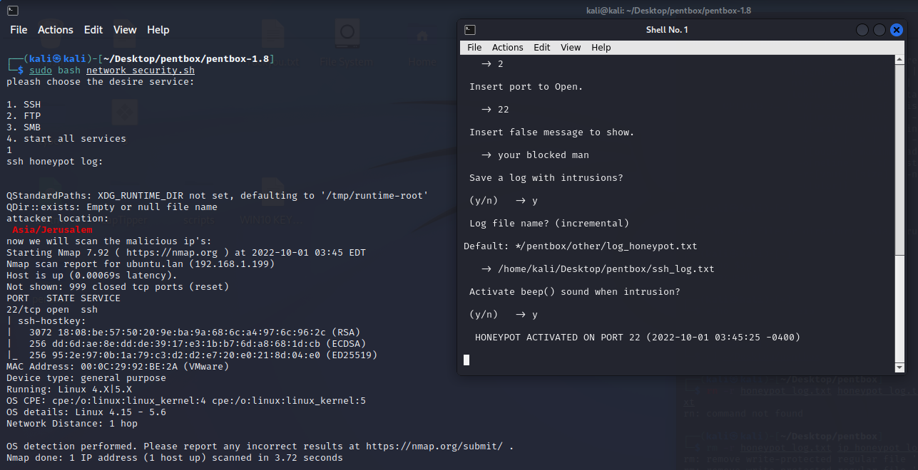

option 4 - all services runs together :

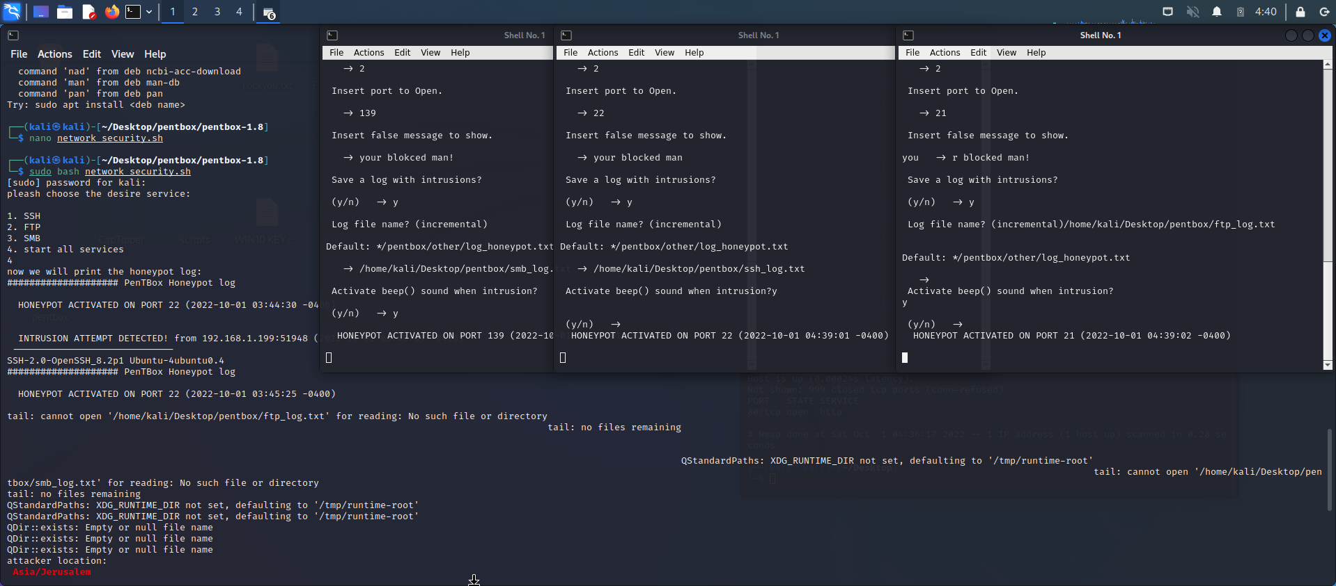

The scripts use expect script for automation pentbox script.